Hospital Patient Pathway Release

Strategic BPMN Model
A high-level process model showing responsibilities, external interactions and the connection to the operational model.

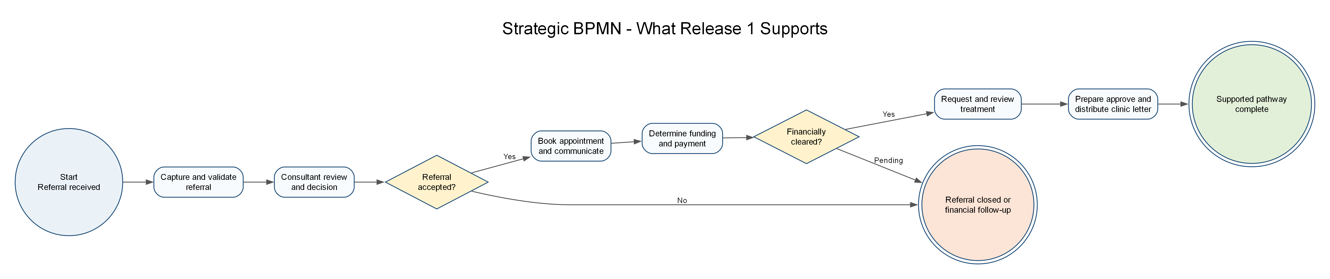
Figure 1 Strategic BPMN model for Release 1

i star Strategic Dependency Model
This presentation view makes the actor dependencies and dependency types readable. The complete SVG source model remains in the strategic-model folder.
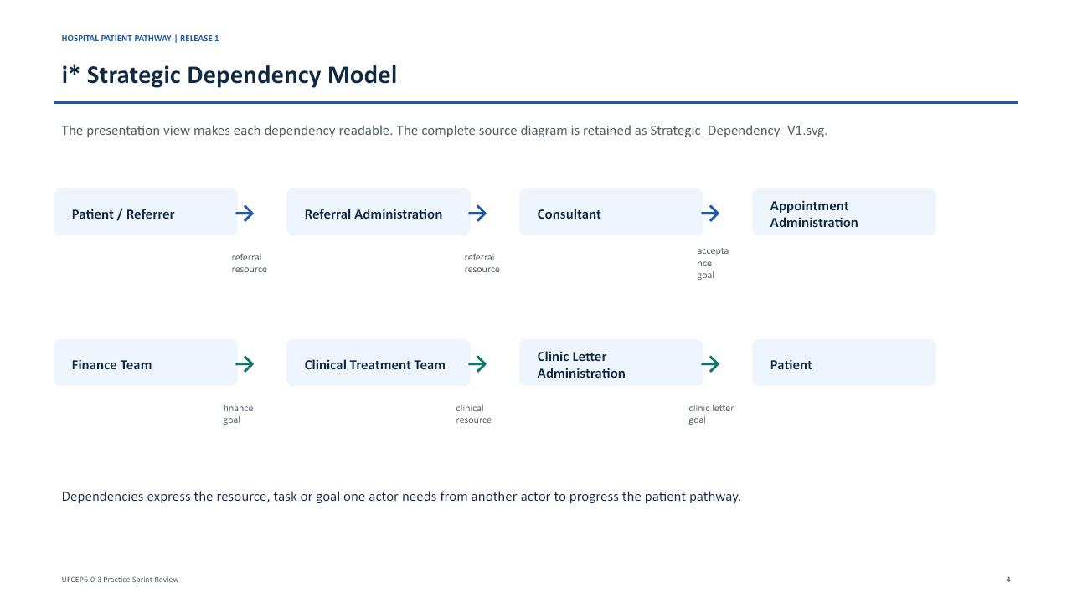
Figure 2 i star Strategic Dependency presentation view

i star Strategic Rationale Model
This presentation view makes goals, tasks and soft goals readable. The complete SVG source model remains in the strategic-model folder.
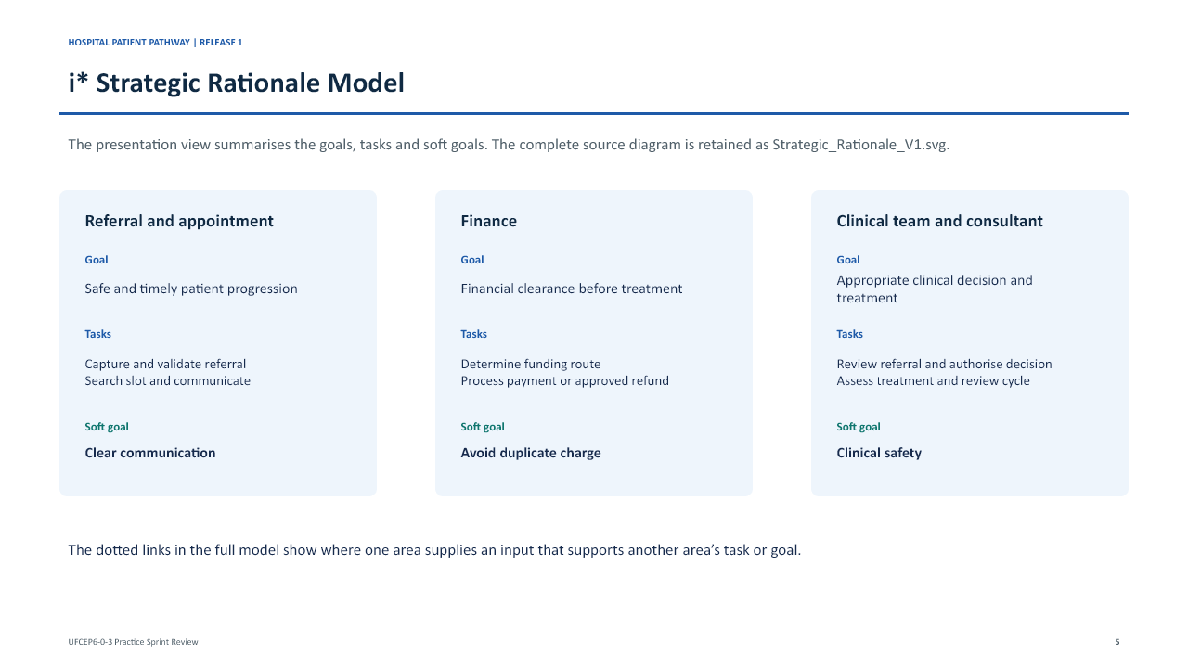
Figure 3 i star Strategic Rationale presentation view

Original Operational BPMN Sub Processes
The following five domain models are the group’s original operational sub-processes. They are called by Hospital_Master_Process.bpmn and have been reorganised only by original owner folder.
Area | Original BPMN sub-process | Owner folder
Referral | Referral Consultant Review | 23084366 DENG JIN WANG
Appointment | Appointment Patient Communication | 23084364 WU JIA WEI
Finance | Funding Payment Refund | 23084362 WU TONG YU
Treatment | Treatment Chemotherapy | 23084368 LIN JIA QIANG
Enquiry | Enquiry Clinic Letter Monitoring | 24000813 XIAO YU YING

Priorities
Define an explicit rework path for pending or rejected funding.
Record consent and information-completeness checks before treatment progresses.
Clarify appointment-to-treatment responsibility and status hand-off.
Capture normal and exception runtime evidence after deployment.

